Thien Mai Do (3424778)
Mabel Le (3443933)
Tien Thanh Vu (3422032)
Busa3007 Blockchain in business
Blockchain-based Smart contract for royalties’ payment in Library
Table of Contents
0
INTRODUCTION 2
CURRENT DATA GOVERNANCE 2
THE CHALLENGES OF CURRENT SYSTEM 3
BLOCKCHAIN SOLUTIONS 4
Overview of the Proposed Solution 4
Proposed Model/Architecture 4
Smart Contract-Based Payment Automation 5
Data Traceability and Audit Mechanism 5
Consensus and Security Mechanisms 5
Governance and Compliance 6
CONCLUSION 6
REFERENCES 8

BLOCKCHAIN-BASED SMART CONTRACT

FOR ROYALTIES’ PAYMENT IN LIBRARY

INTRODUCTION
Digital technology advancement has established the e-Library as a vital platform which enables worldwide academic knowledge sharing and storage and retrieval. The shift of traditional libraries toward digital models serves the requirements of online education and research activities and publication needs (Rao & Ranganadham, 2025). The transition to digital systems brings substantial obstacles which affect data governance through transparency issues and copyright protection and information security and operational performance.

Blockchain technology represents a revolutionary solution which enables organizations to build transparent automated systems for managing data in an unalterable manner. The technology enables better information retrieval while safeguarding intellectual property rights and streamlining copyright payment systems for e-libraries (Mondal, 2021).

The research aims to evaluate present e-Library data governance practices while determining essential obstacles and developing a Blockchain-based smart contract system for royalty payments to demonstrate how this technology works in digital data management.

CURRENT DATA GOVERNANCE
In the era of advanced technology, library systems are gradually transforming their operational models from traditional to digital frameworks. Some libraries have begun examining and implementing advanced technologies such as artificial intelligence (AI) and machine learning (ML) into their system. However, in terms of data governance, they still depend on a single, centralized data management models such as on servers in an information storage facility, fostering the consistency of data management, meanwhile simplifying maintenance and security protocols (GeeksforGeeks, 2024). Some widespread library management software, for example, Koha and LibraryWorld, have been adopted to assist library operations, yet these systems are not comprehensive and still encounter numerous limitations (Forrester, 2025), especially in processing transactions as they likely lack functionalities to handle transactions and payment processing within the library system.

First, ensuring traceability has become an important component of effective data governance in libraries. Traceability allows organizations to track the source of data regarding where it originates, how it is gathered and the adjustments it has experienced. This guarantees that every modification is accurately documented and could be verified properly (Fernández-Iglesias et al., 2024). Moreover, real-time insights into data flows significantly contribute to library administrators with sound visibility and analysis of information changes across the entire systems, assisting the timely detection of inconsistencies or unauthorized alterations.

Furthermore, guaranteeing the data privacy is considered a further primary concern, aiming to maintain secure and authorized access to digital resources. Numerous digital platforms are vulnerable to automated bots leading to account manipulation or data breaches (Team, 2025). The bots that circumvent verification could not only expose sensitive data such as customer information, publication details or system credentials, but also result in credential stuffing or denial-of-service (DoS) attacks (Ross, 2024).

Finally, transparency presents another critical issue. In terms of royalty payment, most e-book libraries and digital platforms still operate under centralized management models controlled by publishers or intermediaries such as banks (Balkwill, 2007). Data on readings, visits or downloads are typically aggregated periodically to calculate the author remuneration, nevertheless, authors are usually not involved directly to verify data sources or revenue calculations, indicating the lack of transparency of the process. Besides, the absence of an independent auditing mechanism also enables data to be altered or deleted without a trace, threatening the reliance and making verification complex during disputes, consequently weakening data integrity and accountability within digital library ecosystems.

THE CHALLENGES OF CURRENT SYSTEM
The centralization system is the primary adoption in libraries, as a result, transparency and autonomy are the concerns of their traditional royalty payment process through intermediaries. Transactions between authors, publishers and libraries often require execution through financial intermediaries such as banks, leading to delays and the absence of direct participation of important stakeholders such as authors in each stage of the payment process. Besides, the internal accounting system could face the obstacle in verifying the actual revenue from each book sold, whereas the author could not verify the number of downloads or revenue received. Therefore, it is suggested that a decentralized payment system could address this problem (Hossain et al., 2020).

Another noticeable limitation of traditional payment systems is the lack of traceability and a reliable audit trail. According to Keating (2024), traditional auditing and logging mechanisms depend heavily on centralized databases and manual reconciliation processes. In spite of maintained historical transaction records, they face several critical drawbacks. Centralized logs are vulnerable to tampering or modification, threatening the integrity of audit data. Moreover, most of the traditional systems demonstrate the weakness of real-time visibility, which is the barrier preventing continuous monitoring and immediate detection of anomalies. Compliance with evolving regulations, such as PCI DSS, GDPR and ISO 27001, is also challenging under these frameworks. Furthermore, centralized systems are put under threat of security risks. When a central server or database fails or is the target of a cyberattack, for example, bot penetration, sensitive data, including internal library operation information and the user database, could be stolen and exposed.

BLOCKCHAIN SOLUTIONS
The proposed Blockchain-based Digital Copyright and Data Governance model addresses three main issues in the current electronic library data management system which include unclear copyright payment processes and limited user control and no way to track transactions and potential security threats from centralized data storage. The proposed model utilizes blockchain technology to optimize data management and payment processes and ownership tracking between authors and publishers and libraries and readers.

Overview of the Proposed Solution
The proposed solution implements a permissioned blockchain system to operate the complete e-library framework. The validating nodes in this system consist of authors publishers and libraries who verify transactions (Usman & Ullah, 2024). The system maintains data integrity and traceability and user privacy protection through its structure which also ensures accountability.

The blockchain model operates differently from conventional centralized systems because it enables automatic revenue distribution through smart contracts and maintains an unalterable transaction history and uses IPFS for decentralized data storage to prevent system breakdowns (Benet, 2014).

The blockchain system maintains permanent records of all book registration and purchase activities which enables both ownership verification and transparent financial transaction tracking.

Proposed Model/Architecture
The proposed model is a Blockchain-based automated copyright payment system designed in a three-layer architecture.

- User Interaction Layer: enables access for authors and publishers and libraries and readers through its interface. Users access the system through MetaMask wallets to view documents and make purchases and track their revenue payments. The system interface uses ReactJS to connect with Web3 API for blockchain interaction.

- Blockchain Governance Layer: as the core operational hub of the system. The Solidity-based smart contract operates as the central automation system for all processes. The system enables work registration and ownership data management through its smart contract functionality. The system determines both the document price and royalty distribution percentages which amount to 80% for authors and 15% for publishers and 5% for libraries. The contract performs automatic payment distribution to all involved parties after reader transactions without requiring any middlemen. The system generates transaction events which enable full auditing transparency.

- Data Storage Layer: The system uses IPFS (InterPlanetary File System) to store actual content while the blockchain maintains document hashes and metadata for efficient storage (Benet, 2014). The system decreases on-chain data storage requirements through this method while preserving work authenticity and enabling full traceability of each document.
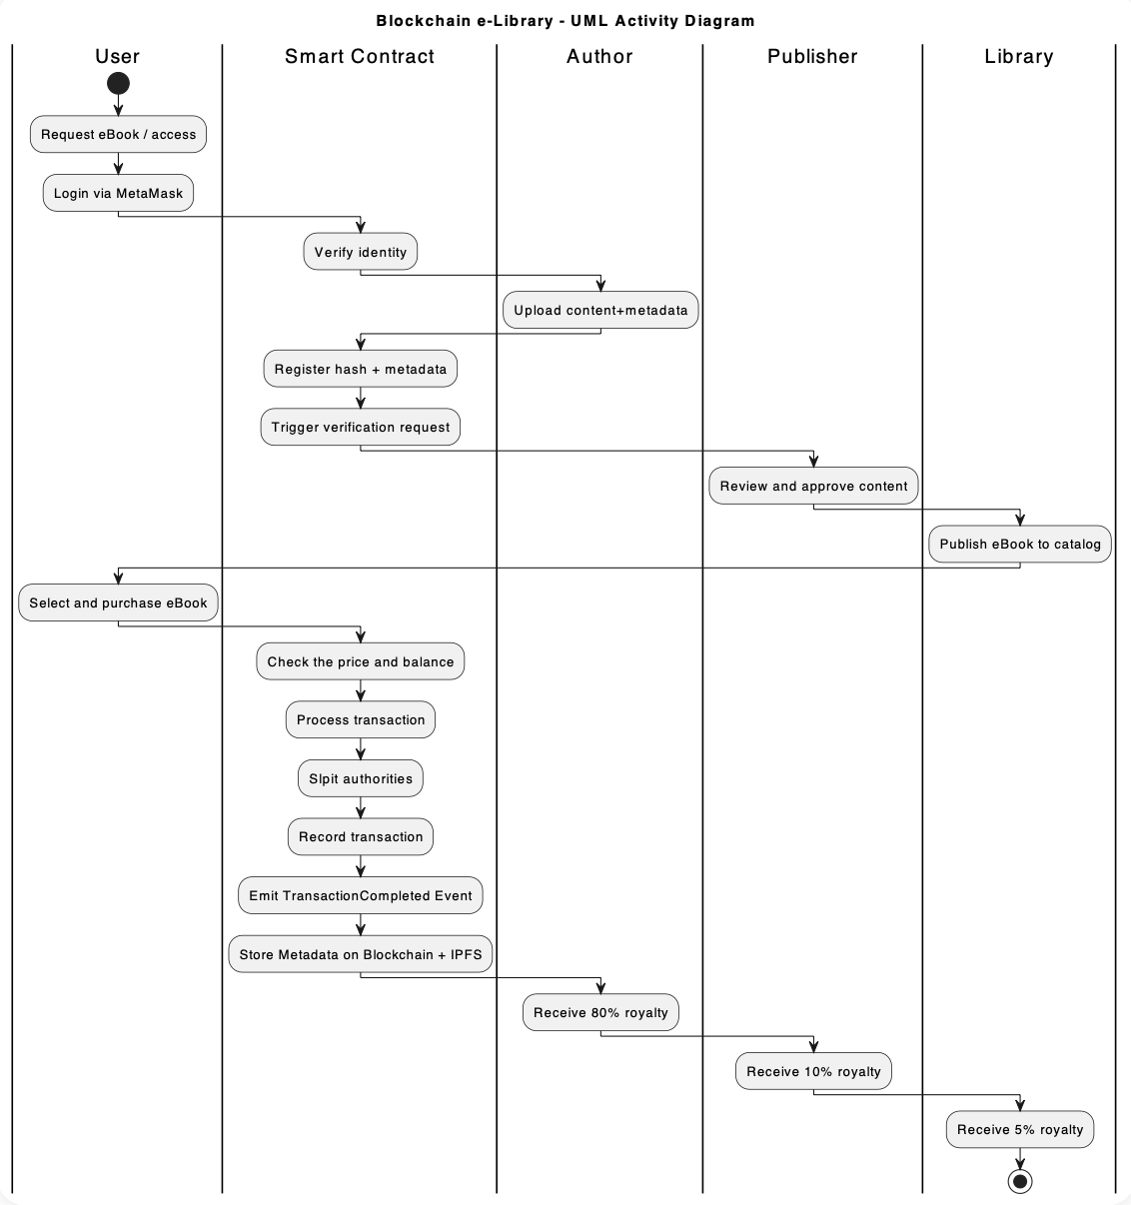
Figure 1: UML Activity Diagram of Blockchain e-Library

Smart Contract-Based Payment Automation
The decentralized payment system of Solidity-based smart contracts functions as a banking alternative that eliminates the need for traditional banking infrastructure. The smart contract system automatically activates when readers buy digital documents through which it handles payments and transaction verification before distributing revenue according to 80% to the author, 15% to the publisher, and 5% to the library. The blockchain maintains permanent transaction records which users can verify through blockchain explorers because of their immutable nature. The decentralized system provides transparent revenue tracking and removes middlemen while enabling authors and publishers to monitor their earnings instantly and reducing payment disputes through automated trustless transactions.

Data Traceability and Audit Mechanism
Every transaction, from registering a work, purchasing reading rights, to paying royalties, is recorded and linked to a unique transaction hash. This creates a transparent chain of custody, allowing us to determine: Who uploaded or edited the document, when the transaction took place, how much royalties were paid to each party.
The distributed ledger system enables real-time verification of all data points which fulfills audit requirements and follows ISO 27001 and GDPR standards as described by Regueiro et al., (2021).

Consensus and Security Mechanisms
The system uses Practical Byzantine Fault Tolerance (PBFT) to validate transactions at high speed with minimal energy usage according to Castro & Liskov (2002). Public/private key encryption protects data security through user authentication and access control functions. The blockchain stores all hashed data permanently which makes it tamper-proof and unalterable. The decentralized network design with no central point of failure protects against server crashes and bot attacks because each node stores the complete data set which enables system operation when any node fails. The method strengthens the platform's security while improving its reliability and operational resilience (Regueiro et al., 2021).

Governance and Compliance
The system grants Digital Identity (DID) to each participant including authors and publishers and libraries and readers while defining their access permissions through Role-Based Access Control (RBAC) (Benantar, 2006).
The author maintains control over copyright ownership through registration and monitoring functions. The publisher checks content validity while handling rights management responsibilities. The library system performs transaction audits while maintaining complete oversight of all operations.
The system implements smart contracts which operate as automated governance tools to enforce policies while blocking human interference. The system follows GDPR and ISO/IEC 27001 and Privacy Act 1988 (Australia) standards to maintain both legal and ethical compliance. The system maintains permanent on-chain records of all actions which enables complete traceability and auditability and protects data confidentiality (Keating, 2024).

Smart Contract Prototype
This project utilizes Solidity for writing smart contracts, Hardhat as a main development framework is being used for compiling, testing, and deploying the smart contract. Additionally, Hardhat ignition was used as a deployment management, and for further upgrades to handle scripts and track deployment. Ether.js is a library used for interacting with Ethereum blockchain Some main functions include registerWork() for registering a new digital book, purchase() function which allows a user to buy a registered e-book with one-time payment, and canAccess() function to check if a specific user has already purchased a certain e-book.
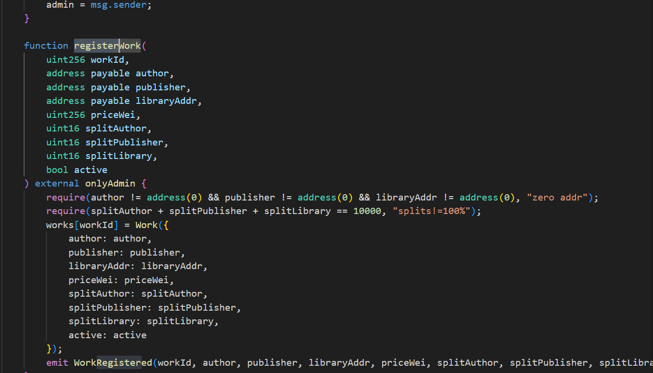
Figure 2
The user can interact with the web interface to create a transaction demand to the smart contract. The contract will be processed and stored the record which make the data permanently being recorded on the blockchain, ensuring the transparency and immutability advantages.

CONCLUSION
The research investigates three main problems in e-library system data governance which stem from insufficient transparency and restricted access and that divides into three distinct layers: application, smart contract and data.

The copyright payment system operates automatically elevated security threats.

A Blockchain-based Data Governance model addresses these system constraints through a permissioned blockchain framework through smart contracts which distribute funds according to an 80-15-5 ratio while encrypted decentralized data storage enhances both data integrity and transparency and auditability.

The proposed solution delivers both high operational performance and accountability and builds stronger trust relationships between authors and publishers and libraries.

The system requires additional evaluation of infrastructure expenses together with legal frameworks and technological readiness for practical deployment.

The system will achieve smart sustainable digital library status through future integration of artificial intelligence (AI) for user behavior analysis and Internet of Things (IoT) for automatic reading and visit tracking.

REFERENCES

References
Balkwill, R. (2007). WIPO-FIP Workshop on IP in the Publishing Industry. https://www.wipo.int/edocs/mdocs/mdocs/en/wipo_ip_wk_del_07/wipo_ip_wk_del_07_www_215605.pdf
Benantar, M. (2006). Access Control Systems. Kluwer Academic Publishers. https://doi.org/10.1007/0-387-27716-1
Benet, J. (2014, July 14). IPFS - Content Addressed, Versioned, P2P File System. ResearchGate. https://www.researchgate.net/publication/263930348_IPFS_-_Content_Addressed_Versioned_P2P_File_System
Buterin, V. (2014). A NEXT GENERATION SMART CONTRACT & DECENTRALIZED APPLICATION PLATFORM. https://www.weusecoins.com/assets/pdf/library/Ethereum_white_paper-a_next_generation_smart_contract_and_decentralized_application_platform-vitalik-buterin.pdf
Castro, M., & Liskov, B. (2002). Practical byzantine fault tolerance and proactive recovery. ACM Transactions on Computer Systems, 20(4), 398–461. https://doi.org/10.1145/571637.571640
Fernández-Iglesias, M. J., Delgado von Eitzen, C., & Anido-Rifón, L. (2024). Efficient Traceability Systems with Smart Contracts: Balancing On-Chain and Off-Chain Data Storage for Enhanced Scalability and Privacy. Applied Sciences, 14(23), 11078. https://doi.org/10.3390/app142311078
Forrester, R. (2025, April 2). Top 5 Library Management Software Solutions for 2025. Five. https://five.co/blog/top-5-library-management-software-solutions/
GeeksforGeeks. (2024, September 30). Centralized Storage System Design. GeeksforGeeks. https://www.geeksforgeeks.org/system-design/centralized-storage-system-design/
Hossain, R., Sarker, D., Sumya Sultana Meem, & Amin, Md. Al. (2020). Analysis of Centralized Payment Eco-System: A Systematic Review on E-Payments. International Journal of Advanced Science and Technology, 29(3), 14139–14159. https://www.researchgate.net/publication/344223983_Analysis_of_Centralized_Payment_Eco-System_A_Systematic_Review_on_E-Payments
Keating, L. (2024, August 6). BLOCKCHAIN-ENABLED AUDIT TRAILS FOR COMPLIANCE AND SECURITY IN CLOUD-BASED PAYMENT SYSTEMS. ResearchGate; unknown. https://www.researchgate.net/publication/395378964_BLOCKCHAIN-ENABLED_AUDIT_TRAILS_FOR_COMPLIANCE_AND_SECURITY_IN_CLOUD-BASED_PAYMENT_SYSTEMS
Mondal, H. (2021, July 9). Application of Blockchain Technology in Library Service: A Study. ResearchGate. https://www.researchgate.net/publication/353123296_Application_of_Blockchain_Technology_in_Library_Service_A_Study
Rao, P. M., & Ranganadham, S. (2025). Adapting to Change: Digital Library Services and Their Role in Remote Learning. International Journal of Research in Library Science, 11(1), 283–293. https://doi.org/10.26761/ijrls.11.1.2025.1856
Regueiro, C., Seco, I., Gutiérrez-Agüero, I., Urquizu, B., & Mansell, J. (2021). A Blockchain-Based Audit Trail Mechanism: Design and Implementation. Algorithms, 14(12), 341. https://doi.org/10.3390/a14120341
Ross, C. F. (2024, October 28). Bad Bots: 6 Common Bot Attacks and Why They Happen. Akamai; Akamai Technologies. https://www.akamai.com/blog/security/bad-bots-6-common-bot-attacks-and-why-they-happen
Team, P. (2024, December 9). The ongoing evolution of public libraries as community hubs. Pressreader.com; PressReader. https://blog.pressreader.com/libraries-institutions/the-ongoing-evolution-of-public-libraries-as-community-hubs
Usman, M., & Ullah, A. (2024). Blockchain Technology Implementation in Libraries: An Overview of Potential Benefits and Challenges. Blockchain Technology Implementation in Libraries: An Overview of Potential Benefits and Challenges, 01(01). https://www.researchgate.net/publication/384812602_Blockchain_Technology_Implementation_in_Libraries_An_Overview_of_Potential_Benefits_and_Challenges

